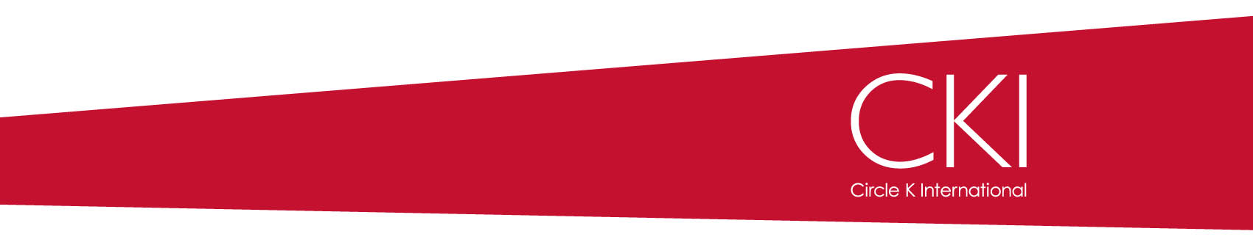

**Kiwanis Family Branches**

**Kiwanis International** – Our parent organization, dedicated to serving the children of the world. Most Circle K clubs have a Kiwanis Club sponsor who helps them and keeps the Circle K club connected with the neighborhood.

**Circle K International** – Us! We’re the largest collegiate community service organization in the world, with thousands of students across the globe dedicating themselves to the CKI tenants of Service, Leadership and Fellowship.

**Key Club International** – Kiwanis International’s Service Leadership Program for high school students. It is the largest and oldest high school service organization in the world. Many of them go on to become Circle K members.

**Builder’s Club** – Kiwanis International’s Service Leadership Program for middle school (or junior high school) students. In total, there are more than 40,000 members worldwide, making it the largest service organization for students of that age.

**K-Kids** – Kiwanis International’s Service Leadership Program for elementary school students. K-Kids include many program that promote leadership potential and encourages students to do well in school.

**Aktion Club** – Kiwanis International Family branch for adults with disabilities. The only service organization of its kind. Aktion Club is the fastest growing branch in the Kiwanis Family.