Circle of Sharing



Official Publication of the Wisconsin- Upper Michigan District of CKI

In this issue

District Goals Update….2

Cody’s Corner………….5

A Note From Morgan….5

**Special Features**

Key Leader………………1

World of Wawbeek…….3

Superior Divisional Rally..4

Metro Divisional Rally…..4

Capital Divisional Rally...4

UW-Milwaukee’s Trick or Treat for STUFH…………..6

Winnebago Divisional Rally……………………….7

Crossword………………..7

**Quick Reference**

Board Contact Info…....8

Upcoming Events…..….8

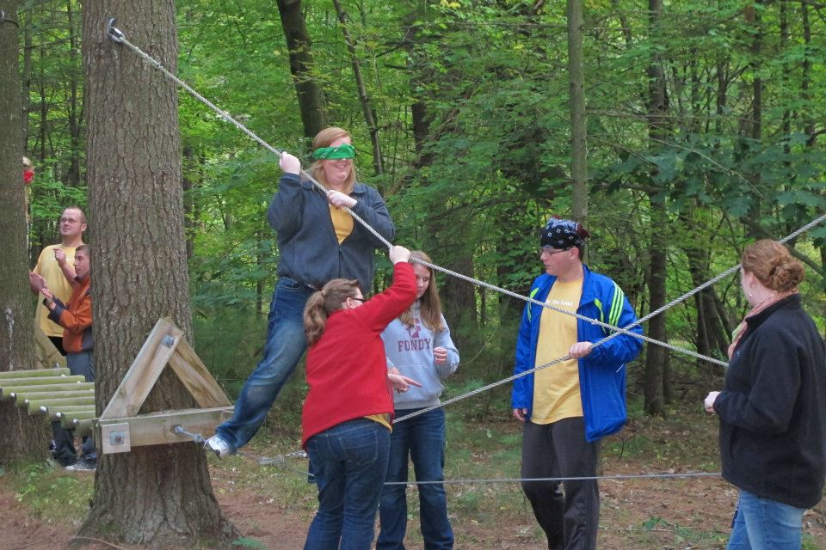

Volume 18 Issue 4 February 2012

Key Leader

**By: Monica Wang**

Since 2005, more than 13,500 students throughout the world have experienced a wonderful weekend of leadership development, team building and the pursuit of excellence. This event, which I have had the joy of experiencing for the second year in a row, is Key Leader. It is open for any high school or college student under the age of twenty-one, even for those who are not in Circle K or Key Club. It was my pleasure to be asked to come back this year as a Student Facilitator by Gail Pachucki, the Key Leader Adult Coordinator and the most hip-hopping, awesome, terrifying-after-curfew grandma there is.

The staff at Key Leader is a welcoming group of district Kiwanians which work to enhance the Key Leader experience for all participants. Each year, there is a different Key Leader Lead Facilitator which guides and directs the participants through activities and team bonding exercises. This year, our Lead Facilitator was Amy White, who has been a party of the Key Leader Family since 2008. All participants are divided into small groups called “Neighborhoods” prior to arrival. Each of these “Neighborhoods” are then led by a Student Facilitator, who are second (or third year) returning participants. This year, there were plenty of old friends of mine who were Student Facilicators with me, including our WUM Circle K Governor, Cody Schara. Our responsibilities were to facilitate participation and discussion in our small groups.

One of my favorite memories of Key Leader would have to be the rope courses. Although they may look easy and straight forward at first, I found out fairly quickly my first year that I am not as balanced or coordinated as I thought I was and I really did need my “spotters” to make sure I didn’t fall. Daringly enough, participants can blindfold themselves to make the courses even more challenging. With the help of their “spotters” and friends, everyone was able to make it through the courses while bonding. There’s nothing quite like holding someone’s hand to help them across or steadying someone who’s lost their balance to really make a new friend.

The sleeping arrangements was very organized and well laid out. There are two different “dorms”, one for the girls and one for the boys. Each room (or conjoined room) has one Student Facilitator who makes sure everyone is in bed by curfew each night and who leads the cleaning process after Key Leader. It really is just like camp, with each room having around eight to twelve participants.

The most meaningful lesson I learned from Key Leader was how to be a servant leader. A servant leader is someone who learns to lead others, not by first being elected into a position of power, but by helping others first with their needs and gaining their trust and support. All the exercises and presentations about respect, growth, integrity, community and so many more really made all of us learn and become servant leaders.

Kiwanians which work to enhance the Key Leader experience for all participants. Each year, there is a different Key Leader Lead Facilitator who guides and directs the participants through activities and team bonding exercises. This year, our Lead Facilitator was Amy White, who has been a part of the Key Leader Family since 2008. All participants are divided into small groups called “Neighborhoods” prior to arrival. Each of these “Neighborhoods” are then led by a Student Facilitator, who is a second (or third year) returning participant. This year, there were plenty of old friends of mine who were Student Facilicators with me, including our WUM Circle K Governor, Cody Schara. Our responsibilities were to facilitate participation and discussion in our small groups.

One of my favorite memories of Key Leader would have to be the rope courses. Although they may look easy and straight forward at first, I found out fairly quickly my first year that I am not as balanced or coordinated as I thought I was and I really did need my “spotters” to make sure I didn’t fall. Daringly enough, participants can blindfold themselves to make the courses even more challenging. With the help of their “spotters” and friends, everyone was able to make it through the courses while bonding. There’s nothing quite like holding someone’s hand to help them across or steadying someone who’s lost their balance to really make a new friend.

The sleeping arrangements was very organized and well laid out. There are two different “dorms”, one for the girls and one for the boys. Each room (or conjoined room) has one Student Facilitator who makes sure everyone is in bed by curfew each night and who leads the cleaning process after Key Leader. It really is just like camp, with each room having around eight to twelve participants.

The most meaningful lesson I learned from Key Leader was how to be a servant leader. A servant leader is someone who learns to lead others, not by first being elected into a position of power, but by helping others first with their needs and gaining their trust and support. All the exercises and presentations about respect, growth, integrity, community and so many more really made all of us learn and become servant leaders.

Page 1

W-UM District Goals 2011-2012 Update

Together we can achieve great things!

In April, the district board got together for new board training and discussed what goals we would like to achieve as a district this year. However, we cannot do it without the help of the membership! Here are some things we can work towards together this year and our progress toward them so far:

**Charter Goals**

Help ensure that at least 20 clubs reach charter strength by March 31, 2012.

*As of right now, we have 17 clubs at charter strength. This is 85% of our goal! Please turn in dues or reactivation forms if you have yet to do so to meet this goal!*

Charter 2 new clubs by March 31, 2012.

*We have worked hard to welcome UW-Milwaukee, Marian, UW-Waukesha, and MSOE as active clubs into our district. We still have a few prospective clubs as well!*

**Membership Goal**

Recruit and retain 600 members by March 31, 2012.

*We currently have 508 members, which is 85% of our goal. Work hard to recruit 5 new members for your club for this month!*

**Service Goal**

Perform at least 14,000 hours of service by March 31, 2012.

*We already have 14,371 service hours. That’s 103% of our goal. Keep pushing to serve!*

**District Event Attendance Goals**

Spring Fling: 100 Circle K’ers and guests

*We had 103 attendees at Spring Fling!* K-Family Service Day: 100 Circle K’ers

MERP : 30 attendees 300 K-Family members total

*We had 47 members at MERP!*  *We had 41 Circle K members*

K-Family Brewer Game: 100 attendees *and 48 total attendees!*

*We had 275 attendees at KFBG!* MAC: 125 members

*W*inter Weekend Getaway: 30 members *We had 121 members at MAC.*

*We had 20 attendees at WWG!* Key Leader: 20 members

K-Family Hockey Night: 120 attendees *We had 12 members attend!*

*We had 137 attendees at KFHN!* District Convention: 175 attendees

**International Event Attendance Goals**

Large-Scale Service Project: 10 members International Convention: 15 members

*We had 11 people attend LSSP. We had 11 people attend*

*ICON.*

**Fundraising Goals**

Camp Wawbeek: $5,000 Camp Baycliff: $1,000

*We already have $4,307.27 raised for We have raised $961, 96% of our*

*Camp Wawbeek, 86% of our goal. goal!*

ELIMINATE: $1,800 Other Charities: $8,200

*We have $2,695.64 raised for our partner We have raised $6,608.62*

*ELIMINATE, which is 150% of our goal. for other charities,*

*which is 81% of our goal.*

Page 2

**By: Val Croissant, Director, Easter Seals WI Camps**

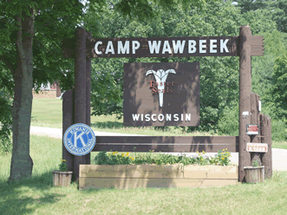

World of Wawbeek

Located just on the edge of Wisconsin Dells, on 400 acres there are two Easter Seals Wisconsin Camps: Camp Wawbeek and Respite Camp. And throughout the years the Kiwanis Family has been a huge part of the Camp Wawbeek Family.

Camp Wawbeek is an overnight camp program for kids and adults with physical disabilities throughout the summer. The campers at Camp Wawbeek love coming to camp because it is a place where they are just like everyone else that might use a wheelchair or that needs additional help with daily activities such as dressing and eating. At Camp Wawbeek campers have the opportunity to go swimming, camping, canoeing, flying down a zip line and hanging out with friends. It really is an experience of a lifetime for the campers that call Camp Wawbeek a second home.

On the lower part of the property, Respite Camp is a year round program for kids and adults with more severe or multiple disabilities. Many of the campers at Respite Camp have cognitive delays, autism, seizure disorders, Down’s syndrome, and other disabilities where they need more attention and care; which works great because at Respite Camp every camper has their own counselor. The word ‘respite’ means ‘to have a break’ which is what our program really gives to the parents and caretakers that are with their loved ones 24 hours a day. Respite Camp has sessions on weekends during the school year and weeks during the summer.

Many Circle K Clubs are already involved with Camp Wawbeek and Respite Camps in a variety of ways, including donating supplies from our needs list, coming to camp for work projects, assisting with programming during the summer, attending Spring Fling, and raising money to help send campers to camp when their family cannot afford it. Thank you so much for everything that you have done! Circle K has a special place in the Wawbeek family and we continue to look forward to working with you throughout the next year.

Also if any individual Circle Ker’s or groups would like to come to camp for a day or two to volunteer and assist the campers with programs, let us know. It is a great way to get to meet some of our wonderful campers. We are looking for some supplies for the summer including: arts and crafts supplies (markers, construction paper, tempera paints), wet wipes, small tents, children’s DVDs, duct tape, etc. We would love for you to stop by to see camp, meet the campers, and drop off your donations.

Another opportunity to help camp is to host a Lily Day in your hometown. Your club would locate a store that would let you stand out in front of (ShopKo, Walmart, grocery stores, etc) and for a day of your choosing hand out lilies for a donation in front on the store (like poppies for Remembrance Day).

If you have any questions or would like to talk about ways your club can help, visit our website: [www.EasterSealsWisconsin.com](http://www.eastersealswisconsin.com/) or contact us: Val Croissant ([vcroissant@wi.easterseals.com](mailto:vcroissant@wi.easterseals.com)) or Ken Saville ([ksaville@wi.easterseals.com](mailto:ksaville@wi.easterseals.com)). Have a wonderful summer and I hope to see you in the next year at Camp Wawbeek.

Page 3

The Superior Division Fall Rally was a great experience and everyone who is able to should go to the next one. At the Fall Rally on November 12, 2011, about 15 students from Michigan Technological University and Northern Michigan University gathered on NMU's campus for a bake sale. The students baked goods beforehand and brought them to sell on campus. We ran the bake sale for about 3 hours in which many tours went by. Because of the tours given to parents that walked by we ended up making about $50 or so in our 3 hours of working. This money went to Camp Baycliff, one of our districts two main camps that we support. After the bake sale was over, we went to Buffalo Wild Wings and had a nice group lunch before heading to watch the MTU vs NMU Football game. Overall the weekend went very well and it helped strengthen the relationship between MTU and NMU.

By: Nathan Swisher, Superior Divsional Lieutenant Governor 2011-2012

Superior Divisional Rally

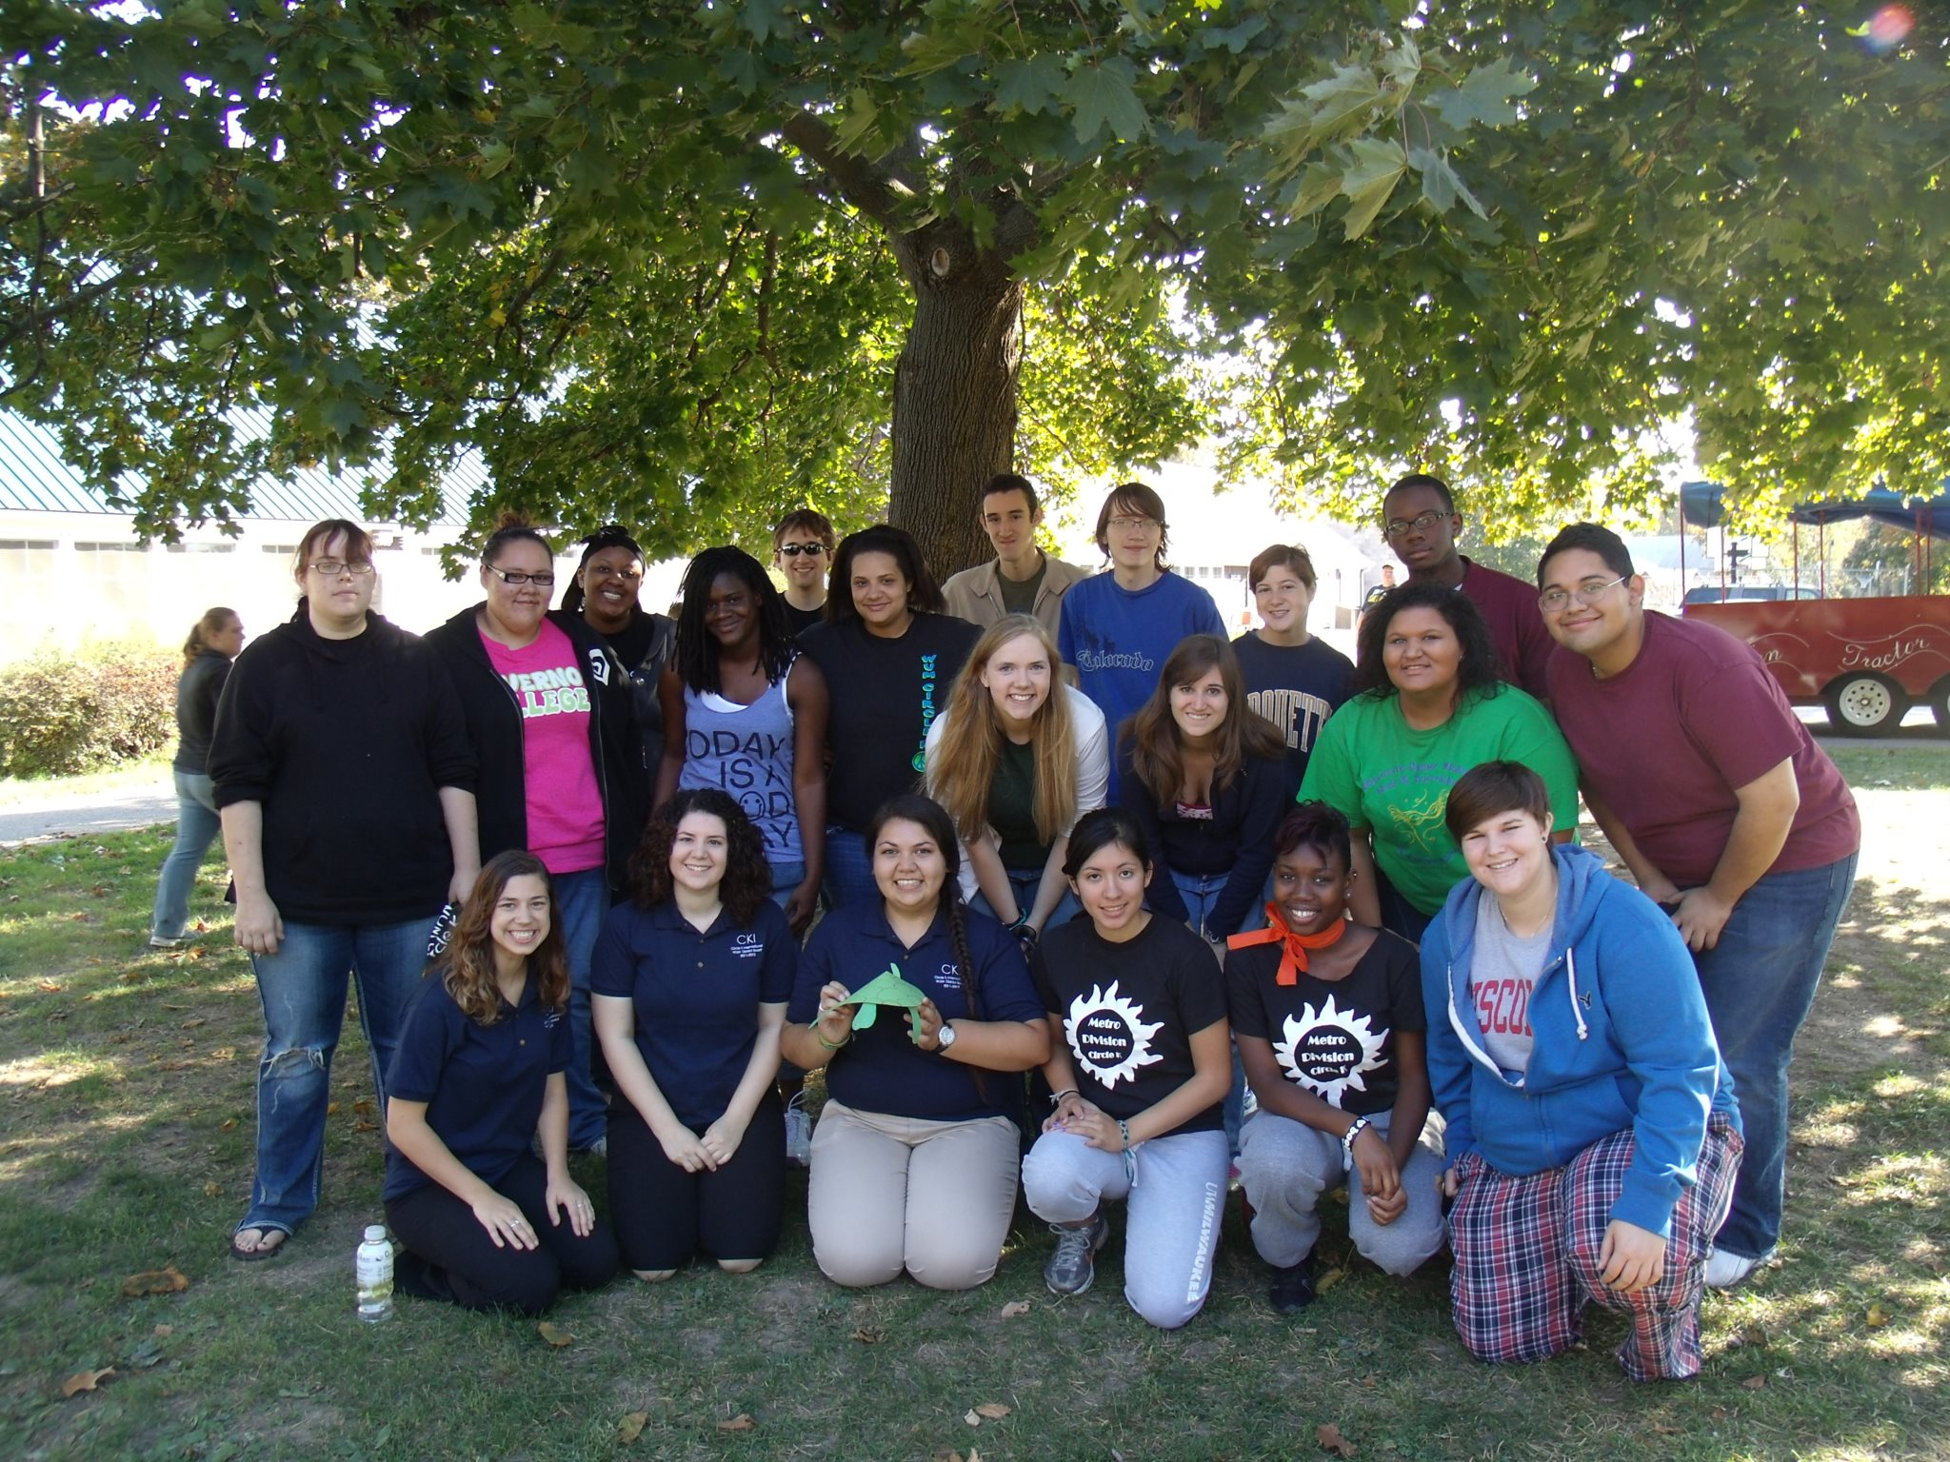

Metro Divisional Rally

By: Morgan Fiero, Metro Divisional Lieutenant Governor 2011-2012

November 19, 2011, Circle K members in the Metro Division came together for service and fellowship. Members from Marquette, MSOE, UW-Milwaukee, and Alverno took in the day to bond and do service. The day started out with introductions and small chats. The main hit was making caramel apples. Each member made their own caramel apples with M&M’s and/or peanuts on them. The moment probably everyone enjoyed was watching me do a tutorial of how to make a caramel apple. With my fellow Metro members watching me, I managed to puncture my hand by pushing the stick straight through the apple. I have to say, we all bonded over that little mishap. The day wasn’t over yet, with five different service projects, we had a scavenger hunt. There were different areas to do a service project and bond with the people in the group. The Metro Division managed to make friendship bracelets, dog toys, Christmas ornaments, Dear Santa Letters, Make a Child Smile cards, and Christmas cards. After running around the UW-Milwaukee campus, we all met back to eat our apples and share some of my favorite icebreakers. My icebreaker workshop included games like, Do You Love Your Neighbor?, Who Did It, Famous Pairs, and the Toilet Paper Game. We all had a lot of fun getting to know each other within the division. Not only did we do service, we got to know each other just a little bit more. As a lieutenant governor, I have had the privilege to get to know the many amazing members from the Metro Division.

Capital Divisional Rally

By: Sarah Nolan, Capital Division Lieutenant Governor 2011-2012

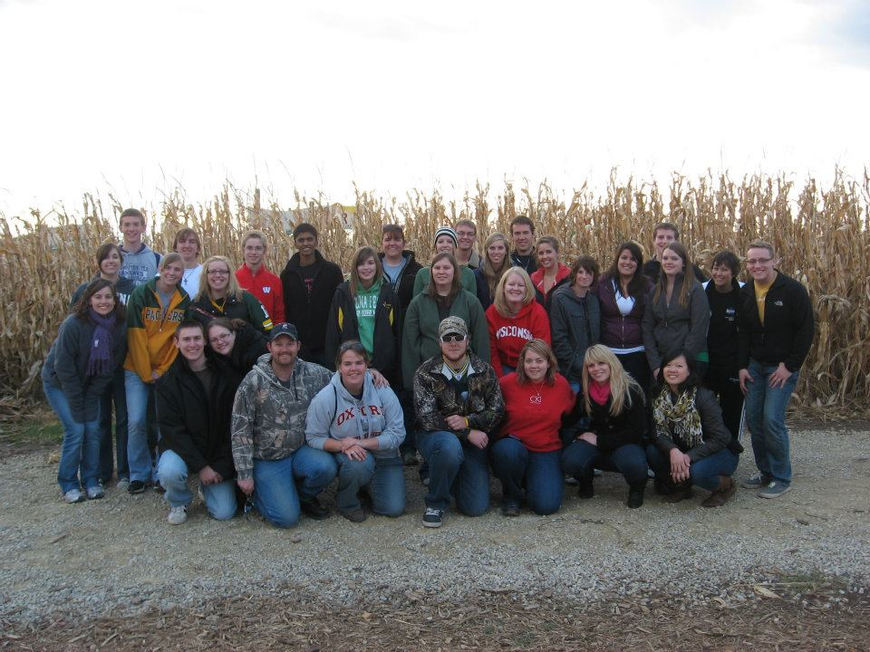

Pumpkins, gourds or whatever you can find to fit in a basket. The Capital Division rally started out with taking a tractor ride back to a hidden field to pick pumpkins, and gourds to fit in the baskets that everyone brought. We then placed all of the baskets in the Schuster’s farm round barn, which they are famous for. The baskets were used in a homeless shelter for the Thanksgiving dinner centerpieces. We then took an adventure and split into groups of four. A competition was started on who could get out of the corn maze the fastest. Some groups cheated but it was fun anyways. To end the night we sat around a fire and had smores and fellowship.

Page 4

Page 5

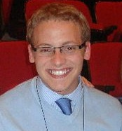

Cody’s C

O

R

N

E

r

Hello WUM! Can you believe that we have just over a month left of this Circle K year? It seems so unreal that all the experiences, service, and memories we have shared are coming to a close. We’ve served our communities tirelessly, as well as the Mobile, Alabama and Virginia Beach communities as well. Moreover, we’ve surpassed our district goal for service hours and there is still time to serve. I’m very proud of all of the work we’ve put into our district and it truly shows. Not only have we out-served this past year, we have expanded our WUM family, by the reactivation of MSOE, UWM, and UW-Waukesha! We are happy to have you in our district and cannot wait to see how you can take us to the next level. I hope everyone has registered for DCON as well. I can guarantee you that this weekend will be one you won’t want to miss. Heck, there are even threats on my safety if you don’t bring your spirit! Keep up the amazing work WUM and I am ready to celebrate with you all in a month!

~Governor Cody Schara



A Note from Morgan

Hello W-UM Circle K’ers! I hope the new semester has been

treating you well. It is hard to think that this Circle K year is almost over.

In the last issue I gave readers an opportunity to win a $20 gift

certificate by answering questions about the information in the Circle of Sharing. I am happy to announce that the winner of the last edition’s prize is Alyssa Rahe! She will be receiving her prize very soon!

I would like to continue to give readers not only an opportunity to read about the K-Family, but also to give everyone an extra reward for staying connected through the W-UM district bulletins. I will have this section in the last issue as well that contains a type of question or puzzle that you can answer or solve. It will be in toward the end of this Circle of Sharing. When you have the answer, all you have to do is email me at [kobylamb@gmail.com](mailto:kobylamb@gmail.com). All of the participants with the correct answer will be pooled, and a winner will be drawn at random to win a $20 gift certificate selected for the issue. The first issues of this edition have been distributed via email to all clubs. If you know someone who would like a copy and does not have one, please let me know and I will get it to you ASAP!

Good luck everyone and make it a great last month of the 2011-2012 Circle K year!

In service,

Morgan Kobylarczyk, District Bulletin Editor 2011-2012

**By: Dezondre Shaw**

UW-Milwaukee’s Treat or Treat for STUFH

Halloween is a time that every little boy and girl look forward to. Well, we at Circle K also like Halloween, but we decided that getting candy wouldn’t be our main goal this year. Instead, we decided to trick or treat for STUFH.

STUFH, Students Team up To Fight Hunger, is a Circle K service partner that strives to link local food banks with universities and colleges across the country. Our club decided to organize a Trick or Treat for STUFH event this past Halloween.

The event went very well; pretty much every home we visited gave us at least three things to donate. We also had many compliments on what we were doing. A lot of community members liked the fact that there are a group of young people in our community that actually want to give back to the community. We had a lot of fun doing the project and in the end we were able to donate over 107 pounds of food.

So if you are interested in the doing this project with your club, here is some things we learned from hosting the event. First of all, make sure you know about other organizations that are asking for donations at the same time. When we did the event, we came to a block of houses that told us that there was another group of students from UWM that came to their door asking for food donations the week before. Some of the people at these homes still donated food to our cause, but our efforts could have been more effective if we would have known about the other group beforehand. Another tip would be to plan your routes well. Make sure you know where you will go if you split into groups because some neighborhoods have many twist and turns and can leave you confused on where you haven’t gone or where you have to go yet. The last and final piece of advice would be to make sure that the community members know you are coming. It increases the chances that people will donate to your cause, and it doesn’t catch them off guard.

UWM had a ton of fun hosting this STUFH event, and we highly encourage other clubs to do the same. STUFH is a great organization and it really brought us together as a club. This event is a great way to get new members involved and really gets your name out in the community!



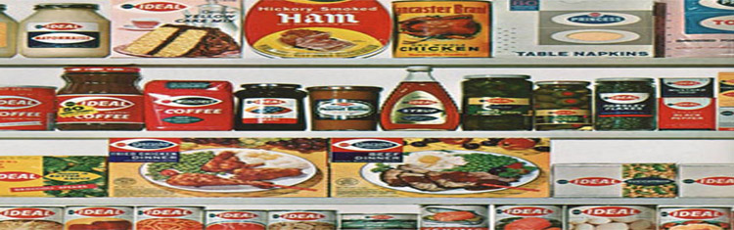

Page 5

Hello Everyone,

I hope you are all having a great second semester and getting lots of service done. I want to thank all who attended the Fall Winnebago Divisional Rally. We had a great turn out, about 30 people from the Winnebago Division and other divisions as well. Thanks again to all who attended! We had a lot of fun eating pizza, watching movies, and hanging out while making blankets. We were able to help Project Linus deliver over 11,000 blankets to children in the area! Great job everyone!

Yours in service,

Kristina Stathas, Winnebago Divisional Lieutenant

Governor 2011-2012

Winnebago Divisonal Rally

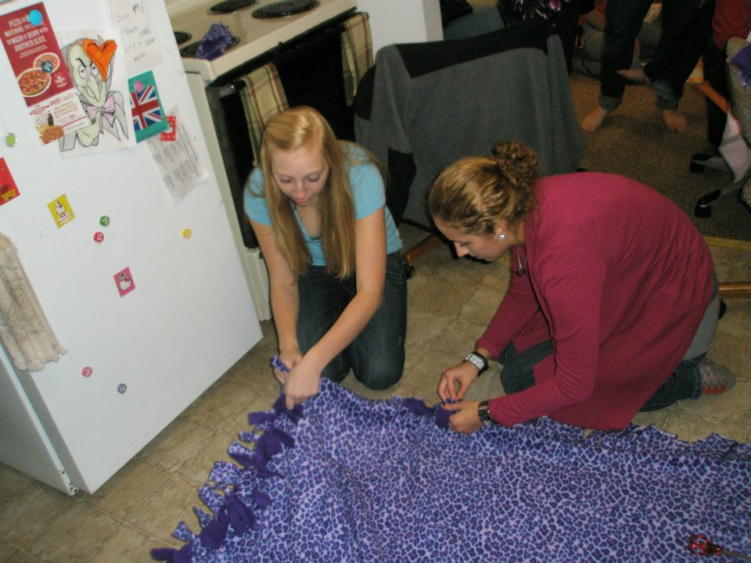

Circle K Crossword

Fill out this crossword and send the answers to the District Bulletin Editor, Morgan Kobylarczyk, at [kobylamb@gmail.com](mailto:kobylamb@gmail.com) for the chance to win a $20 certificate!

|  |  |
| --- | --- |
| **Across** | |
| 1. | The sections that each district is split up into |
| 5. | The middle school branch of Kiwanis |
| 9. | This Circle K partner works to collect books for those who need it |
| 14. | The branch of Kiwanis for adults who live with a disability |
| 15. | This Circle K partner works to rid our planet of maternal and neonatal tetanus and other complications |
| 16. | Our 2011-2012 W-UM District Governor |

|  |  |  |  |  |  |  |  |  |  |  |  |  |  |  |  |  |  |  |  |  |
| --- | --- | --- | --- | --- | --- | --- | --- | --- | --- | --- | --- | --- | --- | --- | --- | --- | --- | --- | --- | --- |
| http://www.armoredpenguin.com/crossword/Images/black.gif | http://www.armoredpenguin.com/crossword/Images/black.gif | http://www.armoredpenguin.com/crossword/Images/black.gif | 1 |  |  |  | 2 |  |  |  | http://www.armoredpenguin.com/crossword/Images/black.gif | 3 | http://www.armoredpenguin.com/crossword/Images/black.gif | http://www.armoredpenguin.com/crossword/Images/black.gif | http://www.armoredpenguin.com/crossword/Images/black.gif | 4 | http://www.armoredpenguin.com/crossword/Images/black.gif | http://www.armoredpenguin.com/crossword/Images/black.gif | http://www.armoredpenguin.com/crossword/Images/black.gif | http://www.armoredpenguin.com/crossword/Images/black.gif |
| http://www.armoredpenguin.com/crossword/Images/black.gif | http://www.armoredpenguin.com/crossword/Images/black.gif | http://www.armoredpenguin.com/crossword/Images/black.gif | http://www.armoredpenguin.com/crossword/Images/black.gif | http://www.armoredpenguin.com/crossword/Images/black.gif | http://www.armoredpenguin.com/crossword/Images/black.gif | http://www.armoredpenguin.com/crossword/Images/black.gif |  | http://www.armoredpenguin.com/crossword/Images/black.gif | http://www.armoredpenguin.com/crossword/Images/black.gif | http://www.armoredpenguin.com/crossword/Images/black.gif | http://www.armoredpenguin.com/crossword/Images/black.gif |  | http://www.armoredpenguin.com/crossword/Images/black.gif | http://www.armoredpenguin.com/crossword/Images/black.gif | http://www.armoredpenguin.com/crossword/Images/black.gif |  | http://www.armoredpenguin.com/crossword/Images/black.gif | http://www.armoredpenguin.com/crossword/Images/black.gif | http://www.armoredpenguin.com/crossword/Images/black.gif | http://www.armoredpenguin.com/crossword/Images/black.gif |
| http://www.armoredpenguin.com/crossword/Images/black.gif | http://www.armoredpenguin.com/crossword/Images/black.gif | http://www.armoredpenguin.com/crossword/Images/black.gif | http://www.armoredpenguin.com/crossword/Images/black.gif | http://www.armoredpenguin.com/crossword/Images/black.gif | 5 |  |  |  |  |  |  |  |  |  |  |  |  | http://www.armoredpenguin.com/crossword/Images/black.gif | http://www.armoredpenguin.com/crossword/Images/black.gif | http://www.armoredpenguin.com/crossword/Images/black.gif |
| http://www.armoredpenguin.com/crossword/Images/black.gif | http://www.armoredpenguin.com/crossword/Images/black.gif | http://www.armoredpenguin.com/crossword/Images/black.gif | http://www.armoredpenguin.com/crossword/Images/black.gif | http://www.armoredpenguin.com/crossword/Images/black.gif | http://www.armoredpenguin.com/crossword/Images/black.gif | http://www.armoredpenguin.com/crossword/Images/black.gif |  | http://www.armoredpenguin.com/crossword/Images/black.gif | http://www.armoredpenguin.com/crossword/Images/black.gif | http://www.armoredpenguin.com/crossword/Images/black.gif | http://www.armoredpenguin.com/crossword/Images/black.gif |  | http://www.armoredpenguin.com/crossword/Images/black.gif | http://www.armoredpenguin.com/crossword/Images/black.gif | http://www.armoredpenguin.com/crossword/Images/black.gif |  | http://www.armoredpenguin.com/crossword/Images/black.gif | http://www.armoredpenguin.com/crossword/Images/black.gif | http://www.armoredpenguin.com/crossword/Images/black.gif | http://www.armoredpenguin.com/crossword/Images/black.gif |
| http://www.armoredpenguin.com/crossword/Images/black.gif | 6 | http://www.armoredpenguin.com/crossword/Images/black.gif | http://www.armoredpenguin.com/crossword/Images/black.gif | http://www.armoredpenguin.com/crossword/Images/black.gif | http://www.armoredpenguin.com/crossword/Images/black.gif | http://www.armoredpenguin.com/crossword/Images/black.gif |  | http://www.armoredpenguin.com/crossword/Images/black.gif | 7 | http://www.armoredpenguin.com/crossword/Images/black.gif | http://www.armoredpenguin.com/crossword/Images/black.gif |  | http://www.armoredpenguin.com/crossword/Images/black.gif | http://www.armoredpenguin.com/crossword/Images/black.gif | http://www.armoredpenguin.com/crossword/Images/black.gif |  | http://www.armoredpenguin.com/crossword/Images/black.gif | http://www.armoredpenguin.com/crossword/Images/black.gif | http://www.armoredpenguin.com/crossword/Images/black.gif | http://www.armoredpenguin.com/crossword/Images/black.gif |
| http://www.armoredpenguin.com/crossword/Images/black.gif |  | http://www.armoredpenguin.com/crossword/Images/black.gif | http://www.armoredpenguin.com/crossword/Images/black.gif | http://www.armoredpenguin.com/crossword/Images/black.gif | http://www.armoredpenguin.com/crossword/Images/black.gif | http://www.armoredpenguin.com/crossword/Images/black.gif |  | http://www.armoredpenguin.com/crossword/Images/black.gif |  | http://www.armoredpenguin.com/crossword/Images/black.gif | http://www.armoredpenguin.com/crossword/Images/black.gif |  | http://www.armoredpenguin.com/crossword/Images/black.gif | http://www.armoredpenguin.com/crossword/Images/black.gif | http://www.armoredpenguin.com/crossword/Images/black.gif | http://www.armoredpenguin.com/crossword/Images/black.gif | http://www.armoredpenguin.com/crossword/Images/black.gif | http://www.armoredpenguin.com/crossword/Images/black.gif | http://www.armoredpenguin.com/crossword/Images/black.gif | http://www.armoredpenguin.com/crossword/Images/black.gif |
| http://www.armoredpenguin.com/crossword/Images/black.gif |  | http://www.armoredpenguin.com/crossword/Images/black.gif | http://www.armoredpenguin.com/crossword/Images/black.gif | http://www.armoredpenguin.com/crossword/Images/black.gif | 8 | http://www.armoredpenguin.com/crossword/Images/black.gif |  | http://www.armoredpenguin.com/crossword/Images/black.gif |  | http://www.armoredpenguin.com/crossword/Images/black.gif | http://www.armoredpenguin.com/crossword/Images/black.gif |  | http://www.armoredpenguin.com/crossword/Images/black.gif | http://www.armoredpenguin.com/crossword/Images/black.gif | http://www.armoredpenguin.com/crossword/Images/black.gif | http://www.armoredpenguin.com/crossword/Images/black.gif | http://www.armoredpenguin.com/crossword/Images/black.gif | http://www.armoredpenguin.com/crossword/Images/black.gif | http://www.armoredpenguin.com/crossword/Images/black.gif | http://www.armoredpenguin.com/crossword/Images/black.gif |
| http://www.armoredpenguin.com/crossword/Images/black.gif |  | http://www.armoredpenguin.com/crossword/Images/black.gif | http://www.armoredpenguin.com/crossword/Images/black.gif | http://www.armoredpenguin.com/crossword/Images/black.gif |  | http://www.armoredpenguin.com/crossword/Images/black.gif |  | http://www.armoredpenguin.com/crossword/Images/black.gif |  | http://www.armoredpenguin.com/crossword/Images/black.gif | http://www.armoredpenguin.com/crossword/Images/black.gif |  | http://www.armoredpenguin.com/crossword/Images/black.gif | http://www.armoredpenguin.com/crossword/Images/black.gif | http://www.armoredpenguin.com/crossword/Images/black.gif | http://www.armoredpenguin.com/crossword/Images/black.gif | http://www.armoredpenguin.com/crossword/Images/black.gif | http://www.armoredpenguin.com/crossword/Images/black.gif | http://www.armoredpenguin.com/crossword/Images/black.gif | http://www.armoredpenguin.com/crossword/Images/black.gif |
| 9 |  |  |  |  |  |  |  |  |  |  |  |  |  |  |  | 10 | http://www.armoredpenguin.com/crossword/Images/black.gif | http://www.armoredpenguin.com/crossword/Images/black.gif | http://www.armoredpenguin.com/crossword/Images/black.gif | 11 |
| http://www.armoredpenguin.com/crossword/Images/black.gif |  | http://www.armoredpenguin.com/crossword/Images/black.gif | http://www.armoredpenguin.com/crossword/Images/black.gif | http://www.armoredpenguin.com/crossword/Images/black.gif |  | http://www.armoredpenguin.com/crossword/Images/black.gif |  | http://www.armoredpenguin.com/crossword/Images/black.gif |  | http://www.armoredpenguin.com/crossword/Images/black.gif | http://www.armoredpenguin.com/crossword/Images/black.gif |  | http://www.armoredpenguin.com/crossword/Images/black.gif | http://www.armoredpenguin.com/crossword/Images/black.gif | http://www.armoredpenguin.com/crossword/Images/black.gif |  | http://www.armoredpenguin.com/crossword/Images/black.gif | http://www.armoredpenguin.com/crossword/Images/black.gif | http://www.armoredpenguin.com/crossword/Images/black.gif |  |
| http://www.armoredpenguin.com/crossword/Images/black.gif |  | http://www.armoredpenguin.com/crossword/Images/black.gif | http://www.armoredpenguin.com/crossword/Images/black.gif | http://www.armoredpenguin.com/crossword/Images/black.gif |  | http://www.armoredpenguin.com/crossword/Images/black.gif |  | http://www.armoredpenguin.com/crossword/Images/black.gif |  | http://www.armoredpenguin.com/crossword/Images/black.gif | http://www.armoredpenguin.com/crossword/Images/black.gif |  | http://www.armoredpenguin.com/crossword/Images/black.gif | http://www.armoredpenguin.com/crossword/Images/black.gif | http://www.armoredpenguin.com/crossword/Images/black.gif |  | http://www.armoredpenguin.com/crossword/Images/black.gif | http://www.armoredpenguin.com/crossword/Images/black.gif | http://www.armoredpenguin.com/crossword/Images/black.gif |  |
| http://www.armoredpenguin.com/crossword/Images/black.gif |  | http://www.armoredpenguin.com/crossword/Images/black.gif | http://www.armoredpenguin.com/crossword/Images/black.gif | http://www.armoredpenguin.com/crossword/Images/black.gif |  | http://www.armoredpenguin.com/crossword/Images/black.gif |  | http://www.armoredpenguin.com/crossword/Images/black.gif |  | http://www.armoredpenguin.com/crossword/Images/black.gif | http://www.armoredpenguin.com/crossword/Images/black.gif |  | http://www.armoredpenguin.com/crossword/Images/black.gif | 12 | http://www.armoredpenguin.com/crossword/Images/black.gif |  | http://www.armoredpenguin.com/crossword/Images/black.gif | http://www.armoredpenguin.com/crossword/Images/black.gif | http://www.armoredpenguin.com/crossword/Images/black.gif |  |
| http://www.armoredpenguin.com/crossword/Images/black.gif |  | http://www.armoredpenguin.com/crossword/Images/black.gif | http://www.armoredpenguin.com/crossword/Images/black.gif | http://www.armoredpenguin.com/crossword/Images/black.gif |  | http://www.armoredpenguin.com/crossword/Images/black.gif | http://www.armoredpenguin.com/crossword/Images/black.gif | http://www.armoredpenguin.com/crossword/Images/black.gif | http://www.armoredpenguin.com/crossword/Images/black.gif | http://www.armoredpenguin.com/crossword/Images/black.gif | http://www.armoredpenguin.com/crossword/Images/black.gif |  | http://www.armoredpenguin.com/crossword/Images/black.gif |  | http://www.armoredpenguin.com/crossword/Images/black.gif |  | http://www.armoredpenguin.com/crossword/Images/black.gif | 13 | http://www.armoredpenguin.com/crossword/Images/black.gif |  |
| http://www.armoredpenguin.com/crossword/Images/black.gif |  | http://www.armoredpenguin.com/crossword/Images/black.gif | http://www.armoredpenguin.com/crossword/Images/black.gif | http://www.armoredpenguin.com/crossword/Images/black.gif |  | http://www.armoredpenguin.com/crossword/Images/black.gif | http://www.armoredpenguin.com/crossword/Images/black.gif | http://www.armoredpenguin.com/crossword/Images/black.gif | http://www.armoredpenguin.com/crossword/Images/black.gif | http://www.armoredpenguin.com/crossword/Images/black.gif | http://www.armoredpenguin.com/crossword/Images/black.gif |  | http://www.armoredpenguin.com/crossword/Images/black.gif |  | http://www.armoredpenguin.com/crossword/Images/black.gif |  | http://www.armoredpenguin.com/crossword/Images/black.gif |  | http://www.armoredpenguin.com/crossword/Images/black.gif |  |
| http://www.armoredpenguin.com/crossword/Images/black.gif |  | http://www.armoredpenguin.com/crossword/Images/black.gif | http://www.armoredpenguin.com/crossword/Images/black.gif | http://www.armoredpenguin.com/crossword/Images/black.gif |  | http://www.armoredpenguin.com/crossword/Images/black.gif | http://www.armoredpenguin.com/crossword/Images/black.gif | http://www.armoredpenguin.com/crossword/Images/black.gif | http://www.armoredpenguin.com/crossword/Images/black.gif | http://www.armoredpenguin.com/crossword/Images/black.gif | http://www.armoredpenguin.com/crossword/Images/black.gif |  | http://www.armoredpenguin.com/crossword/Images/black.gif |  | http://www.armoredpenguin.com/crossword/Images/black.gif |  | http://www.armoredpenguin.com/crossword/Images/black.gif |  | http://www.armoredpenguin.com/crossword/Images/black.gif |  |
| http://www.armoredpenguin.com/crossword/Images/black.gif |  | http://www.armoredpenguin.com/crossword/Images/black.gif | http://www.armoredpenguin.com/crossword/Images/black.gif | http://www.armoredpenguin.com/crossword/Images/black.gif |  | http://www.armoredpenguin.com/crossword/Images/black.gif | http://www.armoredpenguin.com/crossword/Images/black.gif | http://www.armoredpenguin.com/crossword/Images/black.gif | http://www.armoredpenguin.com/crossword/Images/black.gif | 14 |  |  |  |  |  |  |  |  |  |  |
| http://www.armoredpenguin.com/crossword/Images/black.gif |  | http://www.armoredpenguin.com/crossword/Images/black.gif | 15 |  |  |  |  |  | http://www.armoredpenguin.com/crossword/Images/black.gif | http://www.armoredpenguin.com/crossword/Images/black.gif | http://www.armoredpenguin.com/crossword/Images/black.gif |  | http://www.armoredpenguin.com/crossword/Images/black.gif |  | http://www.armoredpenguin.com/crossword/Images/black.gif |  | http://www.armoredpenguin.com/crossword/Images/black.gif |  | http://www.armoredpenguin.com/crossword/Images/black.gif | http://www.armoredpenguin.com/crossword/Images/black.gif |
| http://www.armoredpenguin.com/crossword/Images/black.gif |  | http://www.armoredpenguin.com/crossword/Images/black.gif | http://www.armoredpenguin.com/crossword/Images/black.gif | http://www.armoredpenguin.com/crossword/Images/black.gif |  | http://www.armoredpenguin.com/crossword/Images/black.gif | http://www.armoredpenguin.com/crossword/Images/black.gif | http://www.armoredpenguin.com/crossword/Images/black.gif | http://www.armoredpenguin.com/crossword/Images/black.gif | http://www.armoredpenguin.com/crossword/Images/black.gif | http://www.armoredpenguin.com/crossword/Images/black.gif |  | http://www.armoredpenguin.com/crossword/Images/black.gif |  | http://www.armoredpenguin.com/crossword/Images/black.gif |  | http://www.armoredpenguin.com/crossword/Images/black.gif |  | http://www.armoredpenguin.com/crossword/Images/black.gif | http://www.armoredpenguin.com/crossword/Images/black.gif |
| http://www.armoredpenguin.com/crossword/Images/black.gif | http://www.armoredpenguin.com/crossword/Images/black.gif | http://www.armoredpenguin.com/crossword/Images/black.gif | http://www.armoredpenguin.com/crossword/Images/black.gif | http://www.armoredpenguin.com/crossword/Images/black.gif |  | http://www.armoredpenguin.com/crossword/Images/black.gif | http://www.armoredpenguin.com/crossword/Images/black.gif | http://www.armoredpenguin.com/crossword/Images/black.gif | http://www.armoredpenguin.com/crossword/Images/black.gif | http://www.armoredpenguin.com/crossword/Images/black.gif | http://www.armoredpenguin.com/crossword/Images/black.gif |  | http://www.armoredpenguin.com/crossword/Images/black.gif |  | http://www.armoredpenguin.com/crossword/Images/black.gif |  | http://www.armoredpenguin.com/crossword/Images/black.gif |  | http://www.armoredpenguin.com/crossword/Images/black.gif | http://www.armoredpenguin.com/crossword/Images/black.gif |
| 16 |  |  |  |  |  |  |  |  |  |  | http://www.armoredpenguin.com/crossword/Images/black.gif | http://www.armoredpenguin.com/crossword/Images/black.gif | http://www.armoredpenguin.com/crossword/Images/black.gif |  | http://www.armoredpenguin.com/crossword/Images/black.gif |  | http://www.armoredpenguin.com/crossword/Images/black.gif |  | http://www.armoredpenguin.com/crossword/Images/black.gif | http://www.armoredpenguin.com/crossword/Images/black.gif |
| http://www.armoredpenguin.com/crossword/Images/black.gif | http://www.armoredpenguin.com/crossword/Images/black.gif | http://www.armoredpenguin.com/crossword/Images/black.gif | http://www.armoredpenguin.com/crossword/Images/black.gif | http://www.armoredpenguin.com/crossword/Images/black.gif | http://www.armoredpenguin.com/crossword/Images/black.gif | http://www.armoredpenguin.com/crossword/Images/black.gif | http://www.armoredpenguin.com/crossword/Images/black.gif | http://www.armoredpenguin.com/crossword/Images/black.gif | http://www.armoredpenguin.com/crossword/Images/black.gif | http://www.armoredpenguin.com/crossword/Images/black.gif | http://www.armoredpenguin.com/crossword/Images/black.gif | http://www.armoredpenguin.com/crossword/Images/black.gif | http://www.armoredpenguin.com/crossword/Images/black.gif |  | http://www.armoredpenguin.com/crossword/Images/black.gif | http://www.armoredpenguin.com/crossword/Images/black.gif | http://www.armoredpenguin.com/crossword/Images/black.gif |  | http://www.armoredpenguin.com/crossword/Images/black.gif | http://www.armoredpenguin.com/crossword/Images/black.gif |
| http://www.armoredpenguin.com/crossword/Images/black.gif | http://www.armoredpenguin.com/crossword/Images/black.gif | http://www.armoredpenguin.com/crossword/Images/black.gif | http://www.armoredpenguin.com/crossword/Images/black.gif | http://www.armoredpenguin.com/crossword/Images/black.gif | http://www.armoredpenguin.com/crossword/Images/black.gif | http://www.armoredpenguin.com/crossword/Images/black.gif | http://www.armoredpenguin.com/crossword/Images/black.gif | http://www.armoredpenguin.com/crossword/Images/black.gif | http://www.armoredpenguin.com/crossword/Images/black.gif | http://www.armoredpenguin.com/crossword/Images/black.gif | http://www.armoredpenguin.com/crossword/Images/black.gif | http://www.armoredpenguin.com/crossword/Images/black.gif | http://www.armoredpenguin.com/crossword/Images/black.gif |  | http://www.armoredpenguin.com/crossword/Images/black.gif | http://www.armoredpenguin.com/crossword/Images/black.gif | http://www.armoredpenguin.com/crossword/Images/black.gif |  | http://www.armoredpenguin.com/crossword/Images/black.gif | http://www.armoredpenguin.com/crossword/Images/black.gif |

|  |  |
| --- | --- |
| **Down** | |
| 2. | This turtle is given out to the club with the most enthusiasm at district events |
| 3. | The end of the year event where awards are given out and the new district board is elected |
| 4. | This Circle K partner works to feed all those who are hungry |
| 6. | Our 2011-2012 International President |
| 7. | The sections that Circle K International is split up into |
| 8. | This Circle K partner works to end premature births and problems that threaten the health of babies |
| 10. | The elementary school branch of Kiwanis |
| 11. | The high school branch of Kiwanis |
| 12. | The city that the 2012 International Convention will be held in |
| 13. | The three Circle K tenants are Service, Leadership, and \_\_\_\_ |

Page 7

***Metro LTG***

Morgan Fierro

Alverno College

737 S. 36 St.

Milwaukee, WI 53215

(414) 640-3906

[musicallymorgi@gmail.com](mailto:musicallymorgi@gmail.com)

***Northwoods LTG***

Travis Meyer

UW-Green Bay

2841 Blue Spruce Dr.

Green Bay, WI 54311

(920) 624-2620

travis.meyerwumcki@gmail.com

***Southeast LTG***

Lena Scheibengraber

Alverno College

1825 N. Oakland Ave

Milwaukee, WI 53202

(414) 418-9779

[scheibls@gmail.com](file:///C:\Users\Owner\Downloads\scheibls@gmail.com)

***Superior LTG***

Nathan Swisher

2455 Hwy 52 N Apt 205

Rochester, MN 55901

([586)549-7133](tel:586-549-7133)

[nathanjswisher@gmail.com](mailto:nathanjswisher@gmail.com)

***Winnebago LTG***

Kristina Stathas

UW- Oshkosh

303 Scott Ave.

Oshkosh, WI 54901

(414)507-8246

[kristina.stathas@gmail.com](mailto:kristina.stathas@gmail.com)

***Awards, Regulations, and***

***History Chair***

Jackie Erzinger

Edgewood College

219 North Brooks St.

Apt. 2

Madison, WI 53715

[(920)619-3579](tel:%28920%29619-3579)

[jackie.erzinger@gmail.com](mailto:jackie.erzinger@gmail.com)

***District Convention Chair***

Mollie Spencer

UW-Oshkosh

1197 High Ave Apt 1

Oshkosh WI 54901

(414) 614-1108

[Mspencercki@gmail.com](mailto:Mspencercki@gmail.com)

**Wisconsin-Upper Michigan Circle K District Board 2011-2012**

***K-Family/Outreach Chair***

Emily Condon

Alverno College

2131 N. 118th St.

Wauwatosa, WI 53226

(414)403 9744

[emilycondoncki@gmail.com](mailto:emilycondoncki@gmail.com)

***Membership Development and Growth Chair***

Jenna Baxter

UW Eau Claire

514 D Chancellors Hall

820 University Drive

Eau Claire, WI 54701

(715) 579-3005

[jenna.m.baxter@gmail.com](mailto:jenna.m.baxter@gmail.com)

***Service Chair***

Rachel Coartney

UW-Whitewater

329 N. Tratt St.

Whitewater, WI 53190

(262) 617-8959

[rachelmarie.coartney@gmail.com](mailto:rachelmarie.coartney@gmail.com)

***Special Events Chair***

Jenny Happ

UW-Whitewater

1109 W. Florence St.

Apt. 6

Whitewater, WI 53190

262-515-6361

[happ.jenny@gmail.com](mailto:happ.jenny@gmail.com)

***Webmaster***

VACANT

***Governor***

Cody Schara

Edgewood College

2509 Monroe St, Apt 1

Madison, WI 53711

[(608)495-1288](tel:%28608%29495-1288)

[codyschara@gmail.com](mailto:codyschara@gmail.com)

***Secretary***

Beth Bergstrom

UW- La Crosse

1515 Pine St

229A Wentz Hall

LaCrosse, WI 54601

(608) 434-8994

[bergstrom11@gmail.com](mailto:bergstrom11@gmail.com)

***Treasurer***

Eric Mehring

2719 Banker Road

Fort Atkinson, WI 53538

(920) 650-7654

[mehring.eric@gmail.com](mailto:mehring.eric@gmail.com)

***Bulletin Editor***

Morgan Kobylarczyk

UW- Eau Claire

214 West Sutherland Hall

620 Hilltop Circle

Eau Claire, WI 54701

(920)360-9903

[kobylamb@gmail.com](mailto:kobylamb@gmail.com" \t "_blank)

***Capital LTG***

Sarah Nolan

UW-Whitewater

343 S. Janesville St.

Whitewater, WI 53190

(262) 909-9683

[Nolans24@gmail.com](mailto:Nolans24@gmail.com)

***Chippewa LTG***

Cody Brown

UW-Lacrosse

227 N. 14th

La Crosse WI 54601

(608) 617-2693

[brown.cody204@gmail.com](mailto:brown.cody204@gmail.com)

***Strategic Planning Chair***

Cody Brown

UW-Lacrosse

227 N. 14th

La Crosse WI 54601

(608) 617-2693

[brown.cody204@gmail.com](mailto:brown.cody204@gmail.com)

Upcoming Events

Mark Your Calendars!

2012 Wisconsin-Upper Michigan District Convention

March 23rd-25th

Spring Fling

April 27th-29th

Page 8