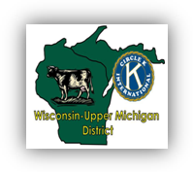

Circle of Sharing

Official Publication of the Wisconsin- Upper Michigan District of CKI

In this issue

District Goals Update….2

Cody’s Corner………….5

A Note From Morgan….5

**Special Features**

MERP Review……..…..…1

K-Family Brewer Game Review………….………1

DCON Awards……..…....2

ICON/LSSP Review…..…3

Subregion C Representative Intro....4

UW-Milwaukee Success Story…………………….6

UW-Green Bay’s Blood Drive……………….……7

**Quick Reference**

Alverno Collge Midnight Masquerade……….…4

K-Family Service Day…..7

Board Contact Info…....8

Upcoming Events…..….8

Volume 18 Issue 3 September 2011

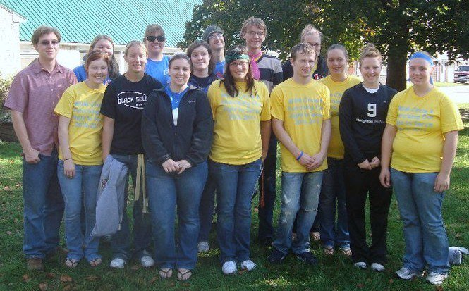

Membership Education Recruitment Program

**By: UW-Platteville**

This was the first official time UW-Platteville went to MERP. We concluded that it was a great time other than that fact that it was really hot. As a club we were able to reconnect with our old friends from Green Bay and Alverno plus we met more of the Michigan people. There’s not much to camping but we enjoyed hosting a fire at our camp site and playing Catch Phrase for most of the afternoon. There was a scavenger hunt that took us around the entire campsite and a great workshop on membership recruitment done by Jenna Baxter. While the district board had their meeting we were able to kill sometime in the Dells; taking random pictures at Old Navy and going go carting. This event was a great reminder of how the tenant “fellowship” fits into Circle K.

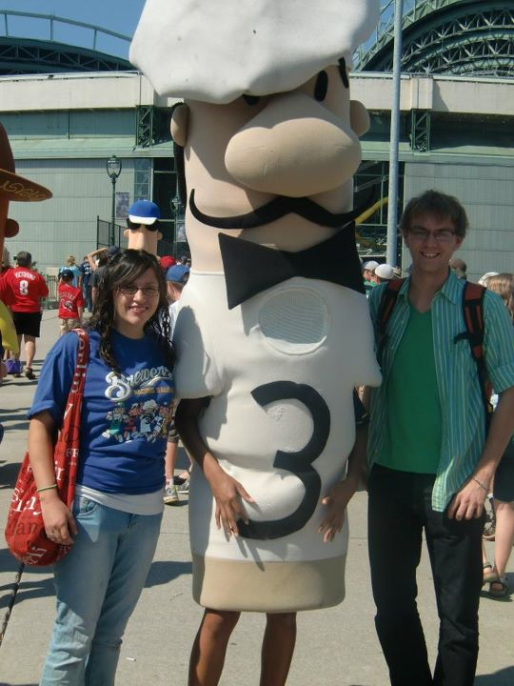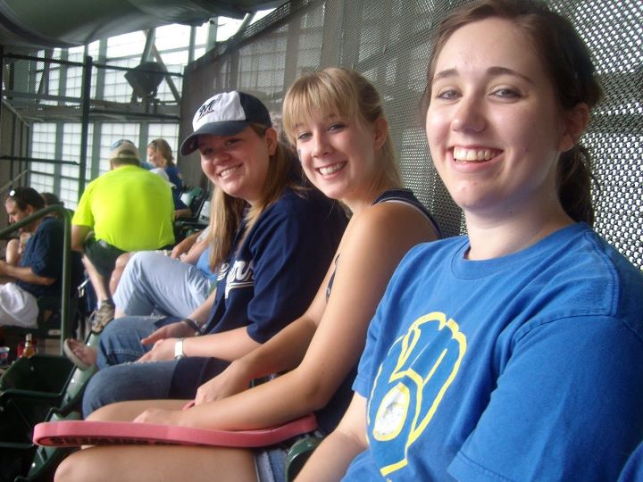

K-Family Brewer Game

**By: Matthew Bowe**

First, I love the Brewers. First, I love the outstanding chance that the

Brewers could make the World Series. First, I love Circle K and everything

within it. I love all three things equally, so they are all firsts. When the

invite to go to a K-Family Brewer game came to me, I was definitely going. It was great seeing old friends attend such a fantastic sport and team. It was nice to see everyone again after such a wonderful summer. It may not have looked like I was paying much attention to others, but I was. All of the females talk about non-baseball related activities after the first inning. Everyone was going everywhere to meet everyone. What was I doing? I was intently concentrating and watching the game while keeping an accurate and precise scorecard. It is legit. The game itself was phenomenal. The Brewers were on a five-game losing streak and on the verge of a four-game sweep by the Phillies. Gallardo, the starting pitcher, had a magnificent performance by only giving up two solo home runs and struck out twelve batters. In the seventh inning, the Brewers scored two runs to take a three to two lead which they did not give up. Francisco Rodriguez held the Phillies in check in the eighth inning, and John Axford notched another save. Did I have fun? Most definitely. Why? Because I was with Circle K and the winning Brewers.

Page 1

District Convention Awards

Hello W-UM CKI! As fall approaches and the leaves

change, the exciting season of District Convention Awards is

also here! As your 2011-2012 Awards, Regulation and History

Chair, I have been hard at work with my committee revamping

all of the awards and stream-lining the application process for members. One of our main goals this year is to make all clubs aware and educated about awards and the application process. We have put all the awards into a new Circle K graphic standards format, and have made applications more clear and club-member friendly. All of the club presidents will receive the 2011-2012 DCON awards disc at the MAC President’s Council. Inside the awards disc will be a tips and tricks sheet, complete with a suggested timeline and great ideas for making applying for awards more fun and exciting! Awards are due on February 3rd, 2012. My goal is to connect with as many members and club presidents as possible to help with questions or concern about award applications. I look forward to seeing all of your application and reading about all your hard work throughout this year. Don’t be afraid to contact me with any questions you may have!

In service,

Jackie Erzinger ’11-’12 Awards, Regulation & History Chair

Together we can achieve great things!

In April, the district board got together for new board training and discussed what goals we would like to achieve as a district this year. However, we cannot do it without the help of the membership! Here are some things we can work towards together this year and our progress toward them so far:

**Charter Goals**

Help ensure that at least 20 clubs reach charter strength by March 31, 2012.

*We are on track for the start of the year!*

Charter 2 new clubs by March 31, 2012.

*There are 4 prospective clubs we can charter. Let’s work hard to include them in the W-UM District!*

**Membership Goal**

Recruit and retain 600 members by March 31, 2012.

*We currently have 629 paid members. Work hard to recruit those new members!*

**Service Goal**

Perform at least 14,000 hours of service by March 31, 2012.

*We have already done 3,469 hours of service! That’s 25% of our goal.*

**District Event Attendance Goals**

Spring Fling: 100 Circle K’ers and guests

*We had 103 attendees at Spring Fling!* K-Family Service Day: 100 Circle K’ers, 300

MERP : 30 attendees K-Family members total

*We had 47 members at MERP!* MAC: 125 members

*W*inter Weekend Getaway: 30 members Key Leader: 20 members

K-Family Hockey Night: 120 attendees District Convention: 175 attendees

**International Event Attendance Goals**

Large-Scale Service Project: 10 members International Convention: 15 members

*We had 11 people attend LSSP. We had 11 people attend ICON.*

**Fundraising Goals**

Camp Wawbeek: $5,000 Camp Baycliff: $1,000

*We already have $2,164.64 raised for*

*Camp Wawbeek, 43% of our goal.*

ELIMINATE: $1,800 Other Charities: $8,200

*We have $1,724 raised for our partner We have raised $1,899.25 for other*

*ELIMINATE, which is 96% of our goal. Charities, which is 23% of our goals.*

Page 2

W-UM District Goals 2011-2012 Update

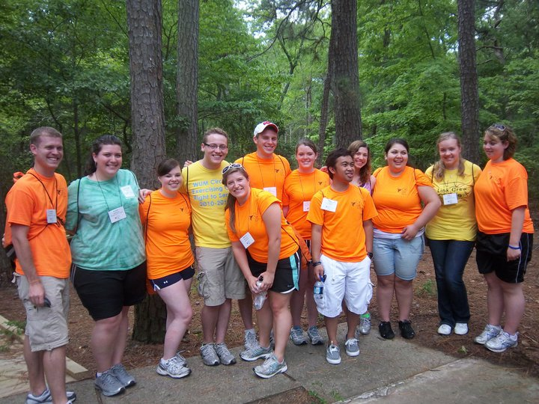

**By: Amanda Marfisi**

Large-Scale Service Project and International Convention 2011

Whether you were at International Convention or not, I’m going to walk

you through the weekend so that you are enticed to attend or come again!

What better way to kick off our organization’s largest event of the year other

than service. I’m talking about the annual Large-Scale Service Project that took

place a couple days prior to convention. Attendees were getting down, dirty, and

a little bit sandy helping out the Virginia Beach community in many ways

including: beach and park cleanups, building habitat homes, reorganizing

warehouses, and even some projects for our service partners. Two days might

have seemed shorter than usual, but that didn’t stop almost 200 CKI members from completing over 3,700 hours of service!

            Don’t let the numbers stop there. We set a goal for ICON this year for number of attendees that we certainly surpassed with 421 people in attendance (106% of our goal)! These attendees were not disappointed. The weekend was jam packed with CKI opportunity. We kicked off opening session with a bang,

a surprise pizza, and of course the superfluous harmonies of district cheers. As I

stood up front to greet everyone, I could have sworn I was in a very eclectic zoo!

From crab hats, to teenage mutant ninja turtles, and pirates to keep them all in line I

was pleasantly relieved to know what dedicated CKI members were under these

outfits.

            Changing into business attire, attendees suited up to attend workshops,

House of Delegates and a few caucus sessions. In each of these attendees

learned the intricacies of the organization as well as the future outlook. Other

than some minor mishaps of technology the House of Delegates sessions ran

smoothly with extremely valuable input from all the members.

            Changing twice more we flew through our awards night only to end up

in one rocking dance Friday night. The awards were plentiful, the recipients

joyful, and the crowd cheering everyone on. W-UM District was recognized with

the Spirit Award; Distinguished District Governor- Jill McCamey; Distinguished

District Committee Chair- Lyssa Bergstrom, Sarah Nolan, and Cody Schara;

Distinguished District; UW-Eau Claire- 1st Place Sapphire Division Growth Enhances Membership Award; and UW-Oshkosh- 3rd Place Sapphire Division Growth Enhances Membership Award! The cheering continued through the dance as a fellow CKI member DJ’ed some tunes for everyone to let loose and get their dance on.

            The highlight of Saturday’s final session was the acts of talent, final farewells, and anticipation of the newly elected board of officers. Talent included singing, ukuleles, and a bit of audience participation. The farewells were done with minimal tears, but great excitement of the accomplishments of the year, and the anticipation still rises as the newly elected board has taken office. This is only a snapshot of LSSP and ICON, and just like the pictures might reflect thousands of words one cannot dream up those words until they attend. With that I encourage you to attend the 2012 International Convention in New Orleans!

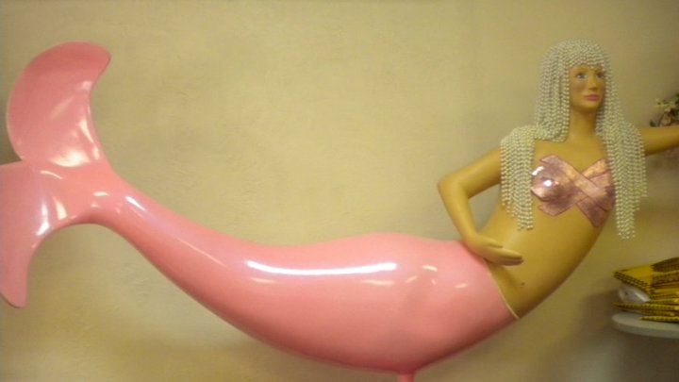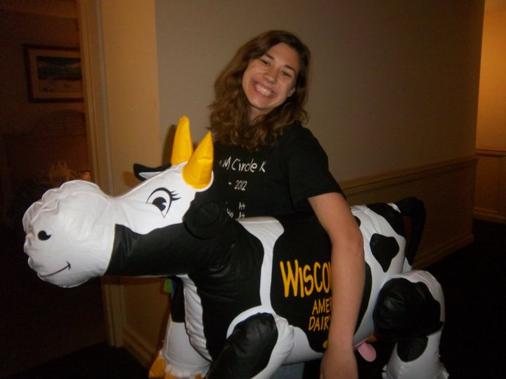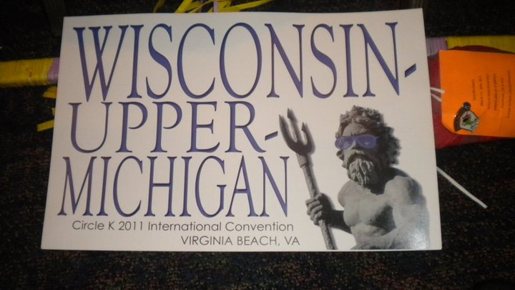

Page 3

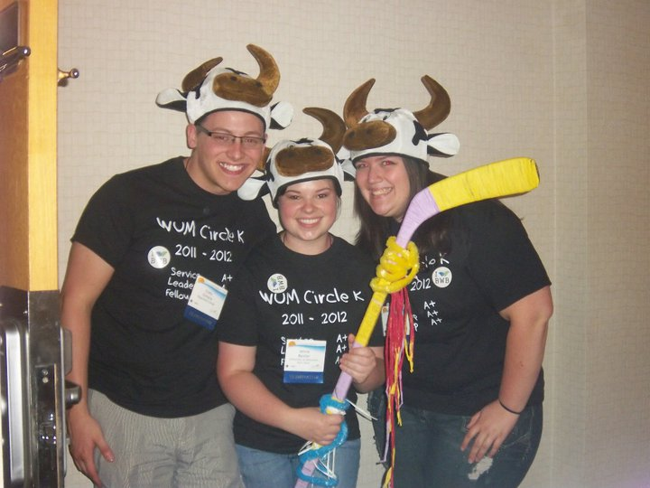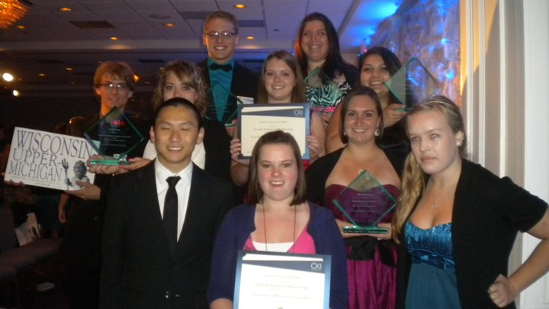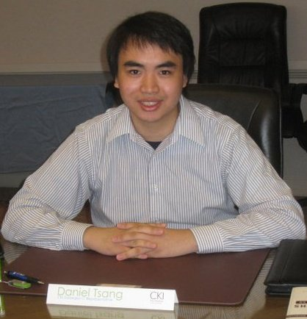

Alverno College Circle K International

invites you to join them at Midnight

Masquerade on October 28 th , from

9pm - Midnight in the Pipeline !

$5.00 Presale Ticket Price or

$8.00 At The Door

(or $5.00 at the door with 3 canned food items!)

Contact a Circle K Member for more info!

Free Food and Drinks!

Tarot Card Readings from 9pm-10pm Halloween Photo Booth from 10pm-11pm Costume Contest at 11:00pm

The Hallows-Eve Hunt at Midnight

For more information please email us at [alvernocirclek@gmail.com](mailto:alvernocirclek@gmail.com)

Greetings Members of the Wisconsin-Upper Michigan District

of Circle K International,

My name is Daniel Tsang and I am your 2011-2012

International Representative for Subregion C. I just wanted to

first start off by saying how much I look forward to meeting

and working with you throughout this year.

I am currently a junior at Loyola University of Chicago, which is located on the north side of the Chicago land area. I am pursing a degree in chemistry with emphasis in biochemistry with a minor in biology. I work as a research assistant at Children’s Memorial Hospital in the Allergy and Immunology Department. Prior to being elected to this position, I was District Treasurer and Lt. Governor for the Illinois-Eastern Iowa as well as Key Club. I have also served as committee chair and committee member for a variety of different committees at the district and international levels. Being an individual who was born and raised in Chicago, I would classify myself as an urban individual. Nature and I sometimes don’t get along. I spend a lot of my time in front of a computer, so if you ever have any questions, concerns, or criticisms, please feel free to send it my way.

As your International Representative, I serve on the Circle K International Board of Officers and represent you and your ideas as a district, as clubs, and as individual members. This means that I not only update you on what’s happening within other districts and across our organization as a whole, but also seek feedback and ideas from you to help our International

Board develop benefits that you

want andprovide resources that

your clubs want and need to grow

and flourish. Please feel free to email

me at [dant1102@yahoo.com](mailto:dant1102@yahoo.com) about

anything; I would love to hear your

input.

I look forward to meeting you in the

distant future. I hope to see you at

Camp Wawbeek in Wisconsin Dells,

Wisconsin for the Membership

Awareness Conference in October.

Serving one day at a time,

Daniel Tsang

’11-’12 Subregion C Representative

Circle K International

Meet our International Representative for Subregion C!



Page 4

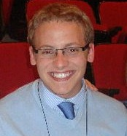

Page 5

Cody’s C

O

R

N

E

r

Hello W-UM! I can’t believe I am sitting here writing you all this update, knowing that our year is halfway over. It just seems like yesterday that we were at DCON, celebrating the achievements our district had made. But, at the same time, I am proud to look at all of the successes and rewarding experiences we’ve all shared this year so far. We’ve surpassed attendance goals at almost every district event, raised $1,100 for the ELIMINATE Project, and are on track to even higher membership totals this year. These are the moments that make me absolutely proud to stand up and tell people that yes; I am the District Governor for the Wisconsin-Upper Michigan District. With the fall season upon us, let’s take this energy and accumulate more service hours, by new and innovative service projects. Even more, let’s involve other members of the Kiwanis Family into these projects. I hope to see you all at Kiwanis Family Service Day on November 5th in Eau Claire. As always, remember to harness that passion, commit with passion, and act upon that passion and this district is going to be in the best shape it has ever been. Keep it up you service monsters!

~Governor Cody Schara

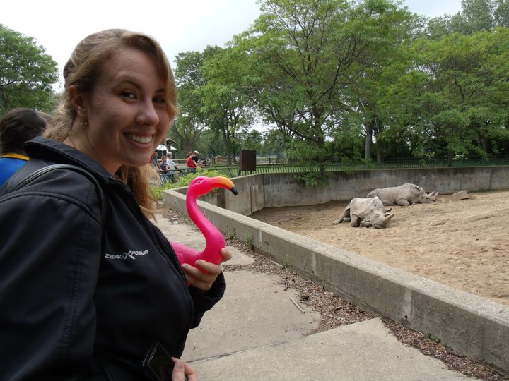

A Note from Morgan

Hello W-UM Circle K’ers! I hope the beginning of the school year is

going swimmingly for all!

In the last issue I gave readers an opportunity to win a $20 gift

certificate by answering questions about the information in the Circle of Sharing. However, I received no emails from anyone. So, I am trying again!

I am providing the readers with not only an opportunity to read about the K-Family, but also to give everyone an extra reward for staying connected through the W-UM district bulletins. I will have this section in every issue that contains a type of question or puzzle that you can answer or solve. When you have the answer, all you have to do is email me at [kobylamb@gmail.com](mailto:kobylamb@gmail.com). All of the participants with the correct answer will be pooled, and a winner will be drawn at random to win a $20 gift certificate selected for the issue. The first issues of this edition will be distributed at the Membership Awareness Conference, and then an electronic copy forwarded by your presidents will follow. If you know someone who would like a copy and does not have one, please let me know and I will get it to you ASAP!

There are 3 questions that you can answer from the articles in this issue for this round of questions. The questions are: Who is our Subregion C International Representative? When are the District Convention Awards applications due? Where will next year’s International Convention be held?

Good luck everyone and have a great school year!

In service,

Morgan Kobylarczyk ’11-’12 W-UM District Bulletin Editor

**By: Kelly Kloth**

UW-Milwaukee’s Recruitment Success

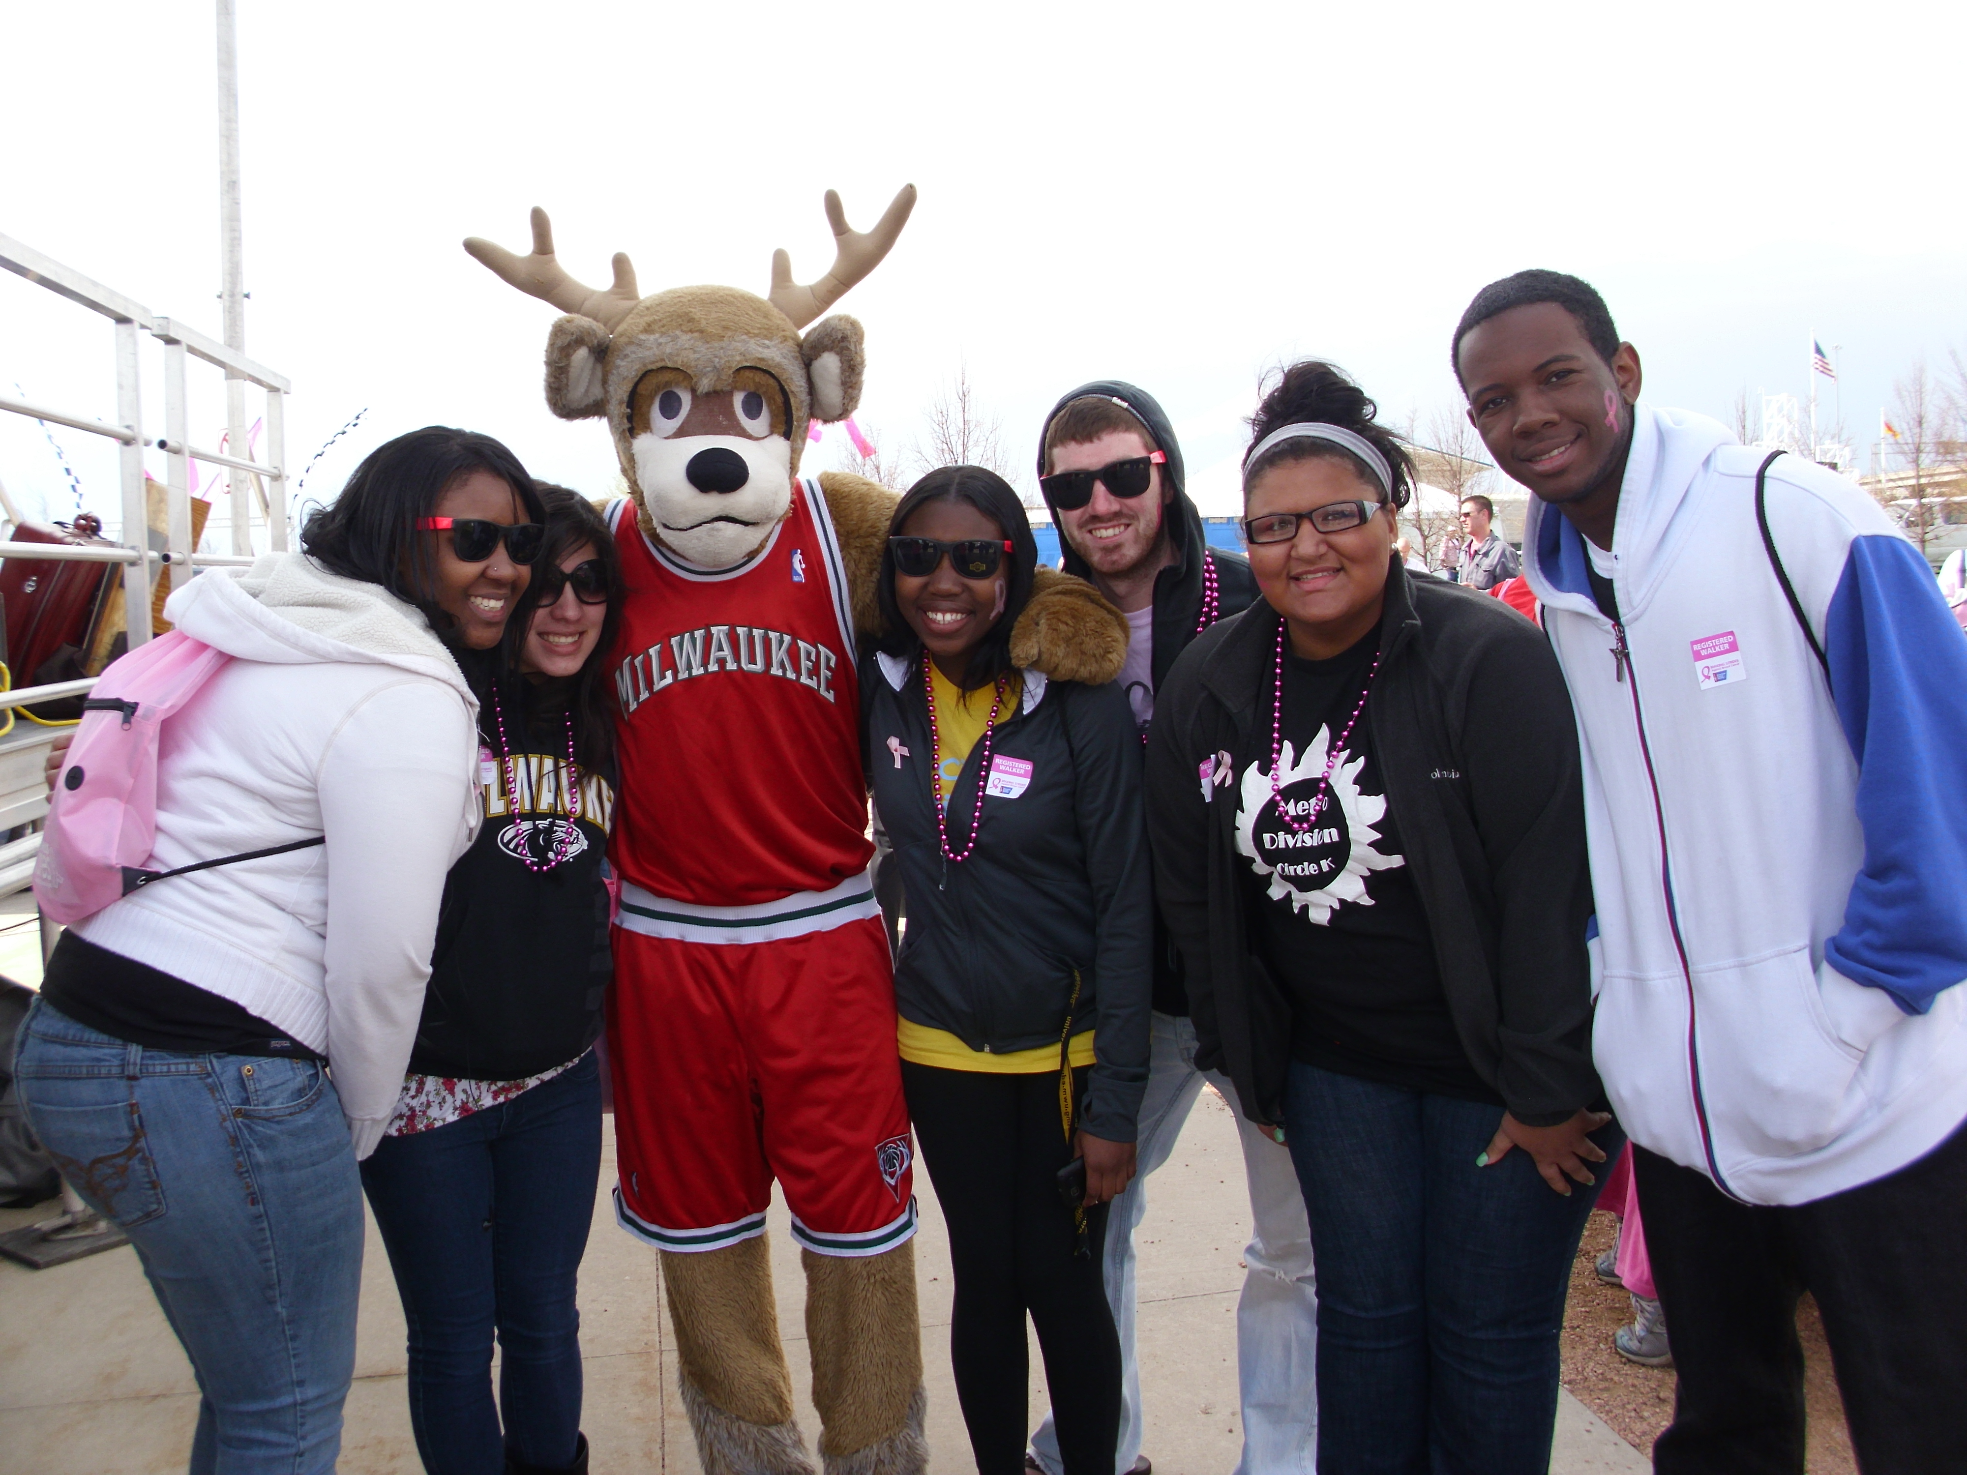

After a few years off the Circle K map, UW-Milwaukee is coming back stronger than ever. It has taken a lot of hard work, but we have found ways to grow our club and achieve our recruitment goals! We are now sharing tips and tricks that have worked for us thus far with you so you can help your club grow as well!

We have formed a recruitment team consisting of the executive board and two very dedicated members. It is the recruitment team’s job to make sure that the word about Circle K is getting out. It is also their job to organize recruitment events and tomake sure that every member feels welcome at meetings and events so members come back to future events.

The biggest thing we have done to promote Circle K on our campus is word of mouth. It has been the most effective tool for us thus far. Everybody in the club has been promoting Circle K to their friends, who then pass it on to their friends etc. Well over 75% of our club members are members because one of their friends was a member before them. Everybody is a prospective member, and it is more effective to speak to somebody face-to-face rather than have somebody look at a flier about your club.

We also had a booth at our campus-wide organizational fair a couple weeks ago. This was EXTREMELY helpful in achieving our recruitment goals and getting the word out about our organization. The key to success with the org fair was planning. The recruitment team had a meeting a few days before the event to make posters and a three-tier board. We also talked about effective ways to talk to prospective members and how to grab peoples’ attention. We had a table at the org fair that we put the three-tier board on. The board was black with gold sparkles for writing with the headline “Circle K.” We included pictures on the board with the three tenants in cursive gold writing. We kept the board simple to draw people in. On the table we had an interest sign-up sheet with name and email. We also had candy scattered across the table for people to grab as they signed up. We also had our mascot “Elfie,” the spirit award we won, as well as the Happy/Sad Jar on the table. We were handing out ramen noodles with info about Circle K, our upcoming events, and how to contact us on them which went over REALLY well. We got a number of compliments from students and staff staying that our table really stood out.

After the organizational fair, we emailed everybody who signed up and let them know about our first meeting and other upcoming events. We also chalked on campus for our first meeting. The email and chalking was extremely effective. I also sent out a reminder email about the first meeting 2 days before the meeting. The reminder email seemed to be very helpful because I received over 12 emails saying either “Thank you.” or “Hey, I can’t make it to the meeting but I am still interested.”

Another key factor in recruiting is making your first meeting interesting. We named our first meeting “Na-Cho Ordinary Meeting” and had a nacho bar. The nacho bar went over really well and attracted a lot of people! At the meeting we had people sign up for MAC and a blood drive we are hosting at UW-Milwaukee with the Red Cross. We had 17 people sign up for MAC and 21 people sign up for the blood drive, which is awesome!

There is no one recruitment strategy that I would say works the best. You have to hit prospective members from all angles in order to be effective. If you work hard, are organized, and are enthusiastic about Circle K, you will have as much success as we have had here at UW-Milwaukee!

Page 5

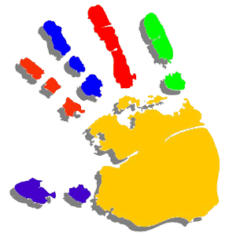

I would like to remind everyone about Cody’s great Governor’s Project this year! As a district we can work together to raise money and school supplies for schools in need. At each district event there will be an opportunity for each school to drop off their school supplies. At least one book bag is needed with every school supplies collection. The school that has the most points, and therefore the best letter grade as a school, will get to help Cody deliver the school supplies and turn Cody into a human sundae! The list of items and points are on the right. Good luck to everyone!

If anyone can help, W-UM can!

**A = 75+**

**B = 55-74 C = 35-54**

Book Bag = 15 points

Binders = 4 points

Pencil Boxes = 1 point

Markers = 3 points

Calculators = 5 points

Pink Erasers = 1 point

Highlighters = 2 points

Notebooks = 1 point

Folders = 1 point

Loose Leaf Paper = 1 point

Colored Pencils = 2 points

Rulers = 1 point

Compasses = 3 points

Watercolor Sets = 5 points

Pencil Top Erasers = 2 points

Pencil Box = 2 points

Pens Box = 2 points

Glue = 1 point

Crayons = 1 point

Kiwanis Family Service Day

Hello Circle K’ers!

My name is Rachel Coartney and I am this year’s Service Chair. As part of my job, I organize and implement Kiwanis Family Service Day. This year, the event is taking place in Eau Claire on November 5th. With this, we spend the day doing service projects all around the city. We are currently working with the humane society, nursing homes, and a few other locations as to help them in any way possible. We hope that you can attend this fun day and take advantage of meeting members from all around the K-Family. If you have any questions, do not hesitate to ask! I look forward to seeing you all on November 5th in Eau Claire.

In service,

Rachel Coartney, ’11-’12 Service Chair

UWGB Circle K Fall 2011 Blood Drive



Ian McArthur at Org Smorg in the Blood Drop costume getting people to sign up for the Blood Drive!

By: Sammy Jackson

Every year UWGB has a fall and spring Blood Drive. This year was

very successful… we were hoping for 77 blood donations, which

means that 90 or so people have to come in. More people have

to come in because some may be turned away; however, this

year we had over 105 people come in! We had lots of people

sign up at Org Smorg the day before the blood drive, and

through the day we always had a few members in the room

between classes working the blood drive. We had many Circle K members donate blood and then volunteer. Some Circle K members made lots of cookies that were devoured by donor’s within the first few hours of Blood Drive. We hope that this will be a good kick off to our year and everything we do will be just as successful.

Page 7

***Metro LTG***

Morgan Fierro

Alverno College

737 S. 36 St.

Milwaukee, WI 53215

(414) 640-3906

[musicallymorgi@gmail.com](mailto:musicallymorgi@gmail.com)

***Northwoods LTG***

Travis Meyer

UW-Green Bay

2841 Blue Spruce Dr.

Green Bay, WI 54311

(920) 624-2620

travis.meyerwumcki@gmail.com

***Southeast LTG***

Lena Scheibengraber

Alverno College

1825 N. Oakland Ave

Milwaukee, WI 53202

(414) 418-9779

[scheibls@gmail.com](file:///C:\Users\kobylamb\AppData\Local\Microsoft\Windows\Temporary%20Internet%20Files\Low\Content.IE5\Downloads\scheibls@gmail.com)

***Superior LTG***

Nathan Swisher

Michigan Technological University

7000 Sandpiper Dr.  
Unit 29  
Houghton, MI, 49931

([586)549-7133](tel:586-549-7133)

[nathanjswisher@gmail.com](mailto:nathanjswisher@gmail.com)

***Winnebago LTG***

Kristina Stathas

UW- Oshkosh

303 Scott Ave.

Oshkosh, WI 54901

(414)507-8246

[kristina.stathas@gmail.com](mailto:kristina.stathas@gmail.com)

***Awards, Regulations, and***

***History Chair***

Jackie Erzinger

Edgewood College

219 North Brooks St.

Apt. 2

Madison, WI 53715

[(920)619-3579](tel:%28920%29619-3579)

[jackie.erzinger@gmail.com](mailto:jackie.erzinger@gmail.com)

***District Convention Chair***

Mollie Spencer

UW-Oshkosh

1197 High Ave Apt 1

Oshkosh WI 54901

(414) 614-1108

[Mspencercki@gmail.com](mailto:Mspencercki@gmail.com)

**Wisconsin-Upper Michigan Circle K District Board 2011-2012**

***K-Family/Outreach Chair***

Emily Condon

Alverno College

2131 N. 118th St.

Wauwatosa, WI 53226

(414)403 9744

[emilycondoncki@gmail.com](mailto:emilycondoncki@gmail.com)

***Membership Development and Growth Chair***

Jenna Baxter

UW Eau Claire

514 D Chancellors Hall

820 University Drive

Eau Claire, WI 54701

(715) 579-3005

[jenna.m.baxter@gmail.com](mailto:jenna.m.baxter@gmail.com)

***Service Chair***

Rachel Coartney

UW-Whitewater

329 N. Tratt St.

Whitewater, WI 53190

(262) 617-8959

[rachelmarie.coartney@gmail.com](mailto:rachelmarie.coartney@gmail.com)

***Special Events Chair***

Jenny Happ

UW-Whitewater

1109 W. Florence St.

Apt. 6

Whitewater, WI 53190

262-515-6361

[happ.jenny@gmail.com](mailto:happ.jenny@gmail.com)

***Webmaster***

VACANT

***Governor***

Cody Schara

Edgewood College

2509 Monroe St, Apt 1

Madison, WI 53711

[(608)495-1288](tel:%28608%29495-1288)

[codyschara@gmail.com](mailto:codyschara@gmail.com)

***Secretary***

Beth Bergstrom

UW- La Crosse

1515 Pine St

229A Wentz Hall

LaCrosse, WI 54601

(608) 434-8994

[bergstrom11@gmail.com](mailto:bergstrom11@gmail.com)

***Treasurer***

Eric Mehring

UW-Platteville

310 D Southwest Hall

1100 Southwest Road

Platteville, WI 53818

(920) 650-7654

[mehring.eric@gmail.com](mailto:mehring.eric@gmail.com)

***Bulletin Editor***

Morgan Kobylarczyk

UW- Eau Claire

214 West Sutherland Hall

620 Hilltop Circle

Eau Claire, WI 54701

(920)360-9903

[kobylamb@gmail.com](mailto:kobylamb@gmail.com" \t "_blank)

***Capital LTG***

Sarah Nolan

UW-Whitewater

343 S. Janesville St.

Whitewater, WI 53190

(262) 909-9683

[Nolans24@gmail.com](mailto:Nolans24@gmail.com)

***Chippewa LTG***

Jordan Arndt

Edgewood College

537 W. Mifflin St.

Madison, WI 53703

(608) 393-4111

[jordancarndt@gmail.com](mailto:jordancarndt@gmail.com)

***Strategic Planning Chair***

Cody Brown

UW-Lacrosse

227 N. 14th

La Crosse WI 54601

(608) 617-2693

[brown.cody204@gmail.com](mailto:brown.cody204@gmail.com)

Page 8

Upcoming Events

Mark Your Calendars!

UW-GB Haunted Morgue:

October 21st- Green Bay, WI

Capital Divisional Rally:

October 23rd- Deerfield, WI

Alverno College Circle K’s Midnight Masquerade:

October 28th- The Pipeline

K-Family Service Day:

November 5th- Eau Claire, WI

Circle K Do More Week:

November 7th-11th- Everywhere!

Kiwanis Family Hockey Night:

December 2nd- Milwaukee, WI